AWS - Cloud Computing

- Cloud Computing?
Cloud Computing is the on demand delivery of compute power database storage applications and other IT services through a cloud services platform via the internet with pay as you go pricing.

- Advantages:
- Cost-Effective
- Scalability
- Accessibility
- Flexibility and Speed
- Backup and Recovery
- Security

Disadvantages:

- Dependence on Internet Connectivity
- Limited Control
- Potential Downtime
- Cost Overruns
- Data Security and Privacy Concerns
- Moving data to other cloud platform

- Types of cloud based on Deployment Models

Public Cloud
- Definition: Services are provided over the internet and shared among multiple organizations.
- Hosted By: Third-party cloud providers (e.g., AWS, Microsoft Azure, Google Cloud).
- Example Use Case: Hosting websites, SaaS applications.
- Advantages: Cost-effective, scalable, no maintenance required by the user.
- Disadvantages: Less control over data and security concerns for sensitive information.

Private Cloud
- Definition: Services are used exclusively by a single organization and hosted either on-premises or by a third-party provider.
- Hosted By: The organization or a dedicated vendor.
- Example Use Case: Banking or government systems that require high security.
- Advantages: More control, enhanced security, and customization options.
- Disadvantages: Higher costs for setup and maintenance.

Hybrid Cloud
- Definition: A mix of public and private clouds, enabling data and applications to be shared between them.
- Hosted By: A combination of private infrastructure and third-party providers.
- Example Use Case: Businesses with sensitive data (stored privately) and less-critical workloads (on the public cloud).
- Advantages: Flexibility, scalability, and cost-effectiveness for non-sensitive workloads.
- Disadvantages: Can be complex to manage and integrate.

Community Cloud
- Definition: A cloud shared by organizations with similar interests or requirements (e.g., healthcare, finance).
- Hosted By: One organization or a third-party vendor.
- Example Use Case: Universities sharing resources for research.
- Advantages: Cost and resource sharing among users with similar needs.
- Disadvantages: Limited scalability compared to public clouds.
- Example : • A group of universities sharing a cloud infrastructure to collaborate on research projects or host shared learning platforms.

- Types of cloud based on service models

a. Infrastructure as a Service (IaaS)
- Definition: Provides virtualized computing resources like servers, storage, and networking.
- Example Providers: AWS EC2, Google Compute Engine, Microsoft Azure.
- Example Use Case: Hosting websites, application development environments.
- Advantages: Complete control over the infrastructure.
- Disadvantages: Requires technical expertise for management.

b. Platform as a Service (PaaS)
- Definition: Provides a platform with tools and frameworks for developers to build, test, and deploy applications.
- Example Providers: Google App Engine, AWS Elastic Beanstalk, Heroku.
- Example Use Case: Developing web or mobile apps.
- Advantages: Simplifies development, no need to manage the underlying infrastructure.
- Disadvantages: Less control over the environment.

c. Software as a Service (SaaS)
- Definition: Provides ready-to-use software applications over the internet.
- Example Providers: Google Workspace, Microsoft 365, Salesforce.
- Example Use Case: Email services, CRM tools, collaboration software.
- Advantages: Easy to use, no maintenance required.
- Disadvantages: Limited customization and dependence on the provider for updates.

d. Function as a Service (FaaS)
- Definition: Allows running individual functions or pieces of code in response to events without managing servers (a subset of serverless computing).
- Example Providers: AWS Lambda, Google Cloud Functions.
- Example Use Case: Running backend services like image processing or notifications.
- Advantages: Cost-efficient, scalable, no server management.
- Disadvantages: Not suitable for long-running applications.

- EC2
Amazon EC2 (Elastic Compute Cloud)
Amazon EC2 is a web service provided by AWS that offers resizable compute capacity in the cloud. It allows users to run virtual servers (instances) on-demand and pay for only what they use. EC2 eliminates the need for upfront investments in hardware and allows scaling up or down based on the workload.

Key Features of EC2:
- Elasticity: Scale resources up or down based on demand.
- Customizable Instances: Choose instance types, operating systems, and configurations.
- Pay-as-You-Go: Pay only for the time your instances are running.
- Secure: Offers VPC (Virtual Private Cloud) for network isolation and security.
- Integration: Works seamlessly with other AWS services like S3, RDS, and IAM.
- Wide Range of Instance Types: Suitable for different workloads (e.g., compute-intensive, memory-intensive, storage-heavy tasks).

Types of Amazon EC2 Instances:
Amazon EC2 instances are categorized based on their purpose and resource optimization:
1. General Purpose Instances
- Description: Balanced compute, memory, and networking. Suitable for a variety of workloads.
- Example Use Cases: Web servers, app servers, and development environments.
- Examples:
  - T Series: T2, T3, T4g (low-cost, burstable performance).
  - M Series: M5, M6g (balanced performance).

2. Compute Optimized Instances
- Description: Optimized for compute-intensive tasks with high-performance processors.
- Example Use Cases: High-performance computing (HPC), scientific modeling, and batch processing.
- Examples:
  - C Series: C5, C6g, C7g.

3. Memory Optimized Instances
- Description: Designed for workloads requiring high memory and fast performance.
- Example Use Cases: Databases, in-memory caching, and real-time big data analytics.
- Examples:
  - R Series: R5, R6g (memory-intensive apps).
  - X Series: X2idn, X2iedn (high memory-to-CPU ratio).
  - z1d: High compute and memory.

4. Storage Optimized Instances
- Description: Designed for workloads requiring high-speed, low-latency storage.
- Example Use Cases: Data warehousing, NoSQL databases, and large-scale data processing.
- Examples:
  - I Series: I3, I4i (low-latency storage).
  - D Series: D2, D3 (dense HDD storage).

5. Accelerated Computing Instances
- Description: Uses GPUs or FPGAs for compute-intensive tasks like machine learning and graphics rendering.
- Example Use Cases: Machine learning inference/training, video processing, and scientific computations.
- Examples:
  - P Series: P3, P4 (GPU-based).
  - G Series: G5, G5g (graphics-intensive tasks).

Pricing Models in Amazon EC2 (Explained with Real-Time Examples)
AWS EC2 offers flexible pricing models designed to suit various workload types and usage patterns. Here’s a detailed explanation of each pricing model with real-world scenarios:

1. On-Demand Instances
- What It Means:
You pay for compute capacity by the second or hour without any long-term commitment. Pricing is higher than other models but offers flexibility.
- Use Case:
Best for short-term, unpredictable workloads or when you’re testing applications.
- Real-Time Example:
Imagine you're a developer working on a new app and need an EC2 instance to test your code. The workload is unpredictable because you don’t know how much time you’ll need. Using On-Demand Instances, you can start and stop your EC2 instance whenever needed, and you’re billed only for the time it’s running.

2. Reserved Instances (RIs)
- What It Means:
By committing to use an EC2 instance for 1 or 3 years, you receive a significant discount (up to 75%) compared to On-Demand pricing. Reserved Instances are best for workloads with predictable usage.
- Use Case:
Ideal for steady-state workloads that run continuously, such as databases or web servers.
- Real-Time Example:
A company hosting a web application for their business knows the application will run 24/7 for at least 2 years. By purchasing a Reserved Instance for 3 years, they save significantly on hosting costs compared to paying On-Demand rates.

3. Spot Instances
- What It Means:
Spot Instances allow you to purchase unused EC2 capacity at discounted rates (up to 90%). These instances can be interrupted by AWS when the capacity is needed by On-Demand users.
- Use Case:
Perfect for non-critical, fault-tolerant workloads, such as batch processing or machine learning model training.
- Real-Time Example:
A video rendering company needs to process high volumes of video files for clients. By using Spot Instances, they can queue rendering jobs and process them at a fraction of the cost, even if the instances are interrupted and jobs are re-queued.

4. Dedicated Instances
- What It Means:
These instances run on physical servers dedicated exclusively to a single customer, ensuring isolation from other AWS customers. Pricing is higher but necessary for workloads with strict compliance or regulatory requirements.
- Use Case:
Ideal for businesses with compliance requirements, such as handling sensitive healthcare or financial data.
- Real-Time Example:
A hospital managing patient records under HIPAA regulations needs strict data isolation. They opt for Dedicated Instances to comply with legal and security standards, ensuring their server is not shared with other AWS customers.

5. Savings Plans
- What It Means:
A flexible pricing model that provides discounts (up to 66%) in exchange for a commitment to a certain level of usage (measured in $/hour) over 1 or 3 years.
- Use Case:
Best for customers who want flexibility across instance families, regions, or operating systems, while still saving money.
- Real-Time Example:
A software-as-a-service (SaaS) company uses multiple types of EC2 instances across different regions for their global clients. By committing to spend $500/month on compute capacity for 3 years through a Compute Savings Plan, they receive a discount and maintain flexibility in how they use their EC2 instances.

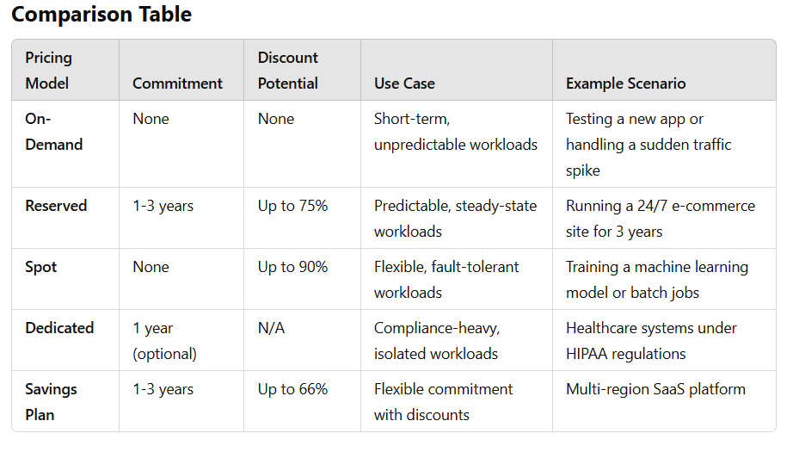

- What is an AMI (Amazon Machine Image)?

An Amazon Machine Image (AMI) is a pre-configured template that contains the necessary information to launch an EC2 instance in AWS. It includes the operating system, application server, applications, libraries, and other settings required to run your workload on an EC2 instance. In simpler terms, an AMI is like a "blueprint" or "template" that AWS uses to create and configure an EC2 instance.

AMI vs. Snapshots
- AMI: A complete image of an EC2 instance (including the OS, applications, and configurations) that can be used to launch new instances.
- Snapshot: A point-in-time backup of a volume, often used to create AMIs or as backups for data. Snapshots are not bootable like AMIs.
- What is Amazon S3 (Simple Storage Service)?
Amazon S3 (Simple Storage Service) is an object storage service provided by AWS. It is used to store and retrieve any amount of data from anywhere on the web. S3 is designed to be scalable, durable, and secure, making it ideal for backup, archival, and content storage.
S3 stores data as objects within buckets. Objects can include files such as images, videos, documents, or even backups of databases, and they can range from a few bytes to several terabytes in size.

Key Features of Amazon S3
Scalability:
S3 is highly scalable, allowing users to store and retrieve any amount of data without worrying about running out of space or provisioning capacity.
Durability:
S3 is designed for 99.999999999% durability (11 nines), meaning your data is highly protected from hardware failures.
Availability:
S3 is designed for 99.99% availability of objects, ensuring that your data is accessible when you need it.
Security:
Amazon S3 integrates with AWS Identity and Access Management (IAM) for access control and provides encryption options to protect your data at rest and in transit.
Cost-Effective:
You pay only for the storage you use and the data you transfer. There are no upfront costs or minimum fees.
Access Control:
You can set permissions on both buckets and objects. These include public and private access controls, as well as access based on user roles.
Versioning:
S3 supports versioning to keep multiple versions of an object in a bucket. This allows you to protect your data from accidental deletion or overwrites.
Lifecycle Policies:
You can define rules to automatically transition your data between storage classes or delete it based on age or other conditions.

Types of Amazon S3 Storage Classes
Amazon S3 offers a variety of storage classes that are optimized for different use cases based on the frequency of access, cost, and durability requirements:
S3 Standard:
Use Case: Frequently accessed data.
Description: This storage class provides low-latency and high-throughput performance, making it ideal for frequently accessed data like active websites, mobile applications, or data analytics.
Cost: Higher than other classes but provides fast access to data.
S3 Intelligent-Tiering:
Use Case: Data with unknown or unpredictable access patterns.
Description: S3 Intelligent-Tiering automatically moves data between two access tiers (frequent and infrequent) based on changing access patterns. It minimizes cost without affecting performance.
Cost: Slightly higher than S3 Standard but optimized for unpredictable workloads.
S3 Standard-IA (Infrequent Access):
Use Case: Infrequently accessed data that needs to be available immediately when accessed.
Description: Designed for long-term storage of data that is infrequently accessed but requires fast retrieval when needed. It has lower storage costs but higher retrieval costs.
Cost: Lower storage costs than S3 Standard, but retrieval is more expensive.
S3 One Zone-IA:
Use Case: Infrequently accessed data that doesn’t need multiple availability zone redundancy.
Description: This storage class stores data in a single availability zone, offering lower storage costs for infrequently accessed data, but with less durability than S3 Standard-IA.
Cost: Even cheaper than S3 Standard-IA but comes with the risk of lower durability.
S3 Glacier:
Use Case: Archival storage where data retrieval times are flexible (e.g., backups, compliance data).
Description: S3 Glacier is designed for long-term archival of data that is rarely accessed and for which retrieval time can be hours to retrieve. It's low-cost storage for data that you don’t need immediately.
Cost: Very low storage costs but retrieval can take several hours or more, with additional costs for retrieval.
S3 Glacier Deep Archive:
Use Case: Extremely infrequently accessed data that is archived for long-term retention (e.g., compliance archives, digital preservation).
Description: This is the lowest-cost storage option and is intended for data that you may need to retrieve once or twice a year, with retrieval times of up to 12 hours.
Cost: Extremely low storage cost, but retrieval is slow and more expensive.

S3 Outposts:
Use Case: Data that needs to remain on-premises for specific compliance or latency requirements.
Description: S3 Outposts is a hybrid storage solution that extends S3 to on-premises AWS Outposts infrastructure.
Cost: Pricing is based on AWS Outposts pricing.

Amazon S3 Bucket and Object Management
Buckets:
A bucket is the top-level container in S3 that holds your objects. You must create a bucket before you can upload objects. Each bucket must have a globally unique name.
Objects:
An object is the actual file or data stored in S3. Objects consist of:
Data: The actual content (e.g., image, video, document).
Metadata: Information about the object (e.g., file size, last modified date).
Unique ID: Every object in S3 is identified by a unique key within the bucket.
Permissions:
You can assign permissions to your S3 buckets and objects to control who can access them. Permissions can be set at the object level or bucket level, and you can use AWS IAM to define specific user access.

S3 Features for Managing Data
Versioning:
What It Is: Allows you to maintain multiple versions of an object in a bucket.
Use Case: Useful for backup and recovery, as well as preventing data loss due to accidental overwrites or deletions.
Lifecycle Policies:
What It Is: S3 allows you to set up lifecycle policies that automatically transition objects between storage classes or delete them after a specified period.
Use Case: Ideal for managing data that changes access patterns over time (e.g., moving old logs from S3 Standard to S3 Glacier).
Cross-Region Replication (CRR):
What It Is: Automatically replicates objects across AWS regions to enhance disaster recovery.
Use Case: Useful for ensuring data availability and compliance with data residency requirements.
Event Notifications:
What It Is: S3 can send notifications (e.g., to SNS, SQS, or Lambda) whenever a certain event occurs in a bucket, such as object creation or deletion.
Use Case: Useful for triggering automated workflows, such as invoking a Lambda function when a new object is uploaded to a bucket.
Encryption:
What It Is: S3 provides options for encrypting your data, both when it is stored (at rest) and during transmission (in transit).
Use Case: Essential for ensuring that your data is secure, especially when dealing with sensitive information.

S3 Pricing
Amazon S3 pricing depends on several factors, including:
Storage Amount: The total amount of data stored in S3.
Data Retrieval: The cost of accessing or retrieving your data, which depends on the storage class (e.g., S3 Glacier retrieval is slower and more costly).
Data Transfer: The cost of transferring data in or out of S3 (data transferred into S3 is free, but data transferred out to the internet is billed).
Requests: The cost of API requests, such as PUT, GET, or LIST operations on your objects.

Real-Time Example of Using Amazon S3
Scenario: Hosting a Website with Static Assets
Web Hosting: You want to host images, CSS, JavaScript, and HTML files for your website on S3.
You store these files in a S3 bucket (e.g., my-website-bucket).
The static website is hosted on S3 using the static website hosting feature, making the content publicly accessible via a URL.
Data Backup: You want to back up large media files (videos, documents) from a media server.
The media files are uploaded to S3 Standard for quick access.
After 30 days, you can automatically move these files to S3 Glacier for long-term storage and cost savings.

- Amazon Elastic Block Store (EBS)
Amazon Elastic Block Store (EBS) is a scalable, high-performance, and persistent block storage service designed for use with Amazon EC2 instances. It provides storage volumes that can be attached to EC2 instances, allowing users to store data and applications persistently.
EBS volumes behave like physical hard drives, which can be formatted with file systems and used like any other block-level storage. You can use them to store data for your applications, databases, and operating systems.

Key Features of EBS:
Persistence: Data on EBS volumes is persistent and remains intact even when the EC2 instance is stopped or terminated.
Scalability: You can create volumes of varying sizes, ranging from 1 GB to 16 TB.
Backup: Snapshots can be taken to back up your data. These snapshots are stored in Amazon S3 and can be restored at any time.
Encryption: EBS volumes can be encrypted for security. Encryption is performed on the data at rest, during transfer, and when the data is written back to the disk.
High Availability and Durability: EBS volumes are replicated within an Availability Zone (AZ), providing durability and high availability.
Performance: EBS offers different performance levels based on the type of volume you choose.

Types of EBS Volumes:
Amazon EBS provides multiple types of volumes, each designed for different use cases based on performance, durability, and cost.
1. General Purpose SSD (gp3 & gp2)
gp3 (New Generation):
Best for: General-purpose workloads like boot volumes, medium-sized databases, and dev/test environments.
Performance: Provides baseline performance of 3,000 IOPS and can scale up to 16,000 IOPS and 1,000 MB/s throughput, regardless of volume size.
Cost: More cost-effective than gp2, offering a lower price for the same level of performance.
gp2:
Best for: General-purpose workloads with moderate performance needs.
Performance: Offers burstable performance. The baseline performance is 3 IOPS per GB, but it can burst to 3,000 IOPS for short periods.
Cost: Less expensive than provisioned IOPS (io1) volumes but higher than standard HDD volumes.
Use Case: Web servers, small to medium-sized databases, development and test environments.
2. Provisioned IOPS SSD (io2 & io1)
io2:
Best for: Applications that require high-performance block storage with low latency and high throughput.
Performance: Offers up to 64,000 IOPS per volume and throughput up to 1,000 MB/s.
Durability: 99.999% durability.
Use Case: I/O-intensive applications like large relational databases (e.g., MySQL, PostgreSQL), SAP, or high-performance workloads.
io1:
Best for: High-performance applications needing consistent IOPS.
Performance: Up to 64,000 IOPS (depending on the instance type) and high throughput.
Cost: More expensive than gp2 and gp3, but offers high performance for demanding workloads.
Use Case: Critical business applications, large transactional databases, high-performance computing (HPC).
3. Throughput Optimized HDD (st1)
Best for: Frequently accessed, throughput-intensive workloads.
Performance: Optimized for large, sequential workloads that require high throughput rather than IOPS. Provides a maximum throughput of 500 MB/s.
Cost: Lower cost compared to SSD-based volumes.
Use Case: Big data, log processing, data warehouses, and other applications requiring sequential read and write operations.
4. Cold HDD (sc1)
Best for: Infrequently accessed data with large volumes.
Performance: Optimized for throughput rather than IOPS. Can provide up to 250 MB/s throughput.
Cost: The least expensive option for storage.
Use Case: Archival data, backup storage, and less frequently accessed data that does not require high performance.
5. Magnetic (standard) [Legacy]
Best for: Previous generation of HDD storage.
Performance: Lower performance compared to SSD-based and newer HDD types.
Cost: Low-cost option, but with trade-offs in performance.
Use Case: Suitable for workloads that require lower throughput and are not sensitive to latency, though it is now considered outdated and typically replaced by st1 or sc1.

EBS Volume Size and Performance
Size: EBS volumes range from 1 GB to 16 TB in size.
Performance: The performance of each EBS volume type can vary depending on its size and type. For example, general-purpose SSDs (gp3) provide good performance for a wide range of use cases, while provisioned IOPS SSDs (io2) are designed for applications that require high throughput and IOPS.
IOPS (Input/Output Operations Per Second): Some volume types allow you to specify the IOPS (e.g., io2), while others, like gp3, provide baseline performance and allow you to scale IOPS independently.

EBS Snapshots
Snapshots: EBS snapshots are point-in-time backups of your EBS volumes. They are incremental, meaning only changes made since the last snapshot are saved.
Storage: Snapshots are stored in Amazon S3 and can be used to restore volumes to a previous state or create new volumes.
Cost: You pay for the storage consumed by the snapshots, and incremental snapshots reduce the cost compared to full backups.
Use Case: Disaster recovery, backup, and migration of volumes between regions.

EBS Pricing
Pricing for EBS is based on several factors:
Volume Type: Different types (e.g., gp3, io2, st1) have different pricing models.
Provisioned IOPS: For io1/io2 volumes, you pay for the IOPS provisioned.
Volume Size: Larger volumes incur higher storage costs.
Snapshot Storage: You pay for snapshot storage, but incremental backups reduce the cost compared to full backups.

Real-World Example Scenarios for EBS Volumes:
gp3 (General Purpose SSD):
Use Case: A development team running web servers on EC2 instances would use gp3 volumes to store their application data and logs.
Reason: Affordable, balanced performance, and scalability.
io2 (Provisioned IOPS SSD):
Use Case: An enterprise using MySQL for transactional processing or high-performance applications such as ERP systems would require io2 volumes.
Reason: Provides consistent and high IOPS for latency-sensitive workloads.
st1 (Throughput Optimized HDD):
Use Case: A media streaming platform that stores video files would benefit from st1 volumes to handle large files and sequential read/write operations.
Reason: Optimized for throughput-intensive workloads and cost-effective.
sc1 (Cold HDD):
Use Case: A backup solution that stores infrequently accessed data such as archival logs or historical data.
Reason: Inexpensive option for cold storage with less frequent access needs.

- Amazon Elastic File System (EFS)
Amazon Elastic File System (EFS) is a fully managed, scalable, and elastic Network File System (NFS) that can be accessed by multiple Amazon EC2 instances simultaneously. It provides shared file storage for a wide range of use cases, including web servers, content management, and enterprise applications.
Unlike EBS, which provides block-level storage attached to a single EC2 instance, EFS allows for the concurrent access of file data by multiple instances, making it ideal for shared storage in distributed applications.

Key Features of Amazon EFS:
- Fully Managed: EFS handles all the infrastructure and management tasks for you, so you can focus on building and running applications without worrying about provisioning, patching, or scaling the file system.
- Scalable: EFS automatically scales your storage capacity up or down based on your application's needs. You only pay for the storage you use, which makes it easy to handle changing workloads.
- Elastic: Storage grows and shrinks automatically based on usage, so you don't need to manually resize your file system.
- Shared Access: EFS allows multiple EC2 instances (within the same region) to access data at the same time. It's a distributed file system that provides high throughput and low-latency file access.
- High Availability and Durability: EFS stores data across multiple Availability Zones (AZs) to provide high availability and durability. It is designed for 99.99% availability and 11 9's of durability.
- Secure: EFS supports data encryption both in transit and at rest. It integrates with AWS Identity and Access Management (IAM) to control who can access your data.

Types of Amazon EFS
Amazon EFS primarily offers one type of file system, but you can configure it for different performance modes and throughput modes to tailor it to your application's requirements.
1. Performance Modes
- General Purpose Mode (Default):
  - Best for: Most file system workloads, including web servers, content management systems, and development environments.
  - Performance: Provides low latency and high throughput suitable for a wide range of applications.
  - Use Case: Common web applications, shared environments, CMS, and applications with moderate I/O performance needs.
- Max I/O Mode:
  - Best for: Applications that require very high throughput and can tolerate higher latency.
  - Performance: Provides higher throughput by enabling horizontal scaling of throughput. However, it can result in slightly higher latencies.
  - Use Case: Big data applications, media processing, and other workloads that require high throughput but can tolerate slightly slower response times.
2. Throughput Modes
- Bursty Throughput (Default):
  - Best for: Applications that experience short periods of high throughput with average or below-average data access patterns.
  - Performance: Provides bursts of throughput, with a baseline throughput that is proportional to the size of the data in the file system.
  - Use Case: Applications with variable or unpredictable throughput needs, such as website file storage, application logs, or shared file systems for multiple users.
- Provisioned Throughput:
  - Best for: Applications with consistent, high throughput needs that can't rely on burstable throughput alone.
  - Performance: Allows you to specify a desired throughput level (in MB/s) independently of the file system size.
  - Use Case: Large-scale databases, media processing workflows, or data analytics workloads that require sustained, high throughput.

Pricing
EFS pricing is based on two primary factors:
- Storage Cost: You are billed based on the amount of data stored in the file system. There are different storage classes that may influence pricing.
  - Standard Storage: Suitable for active, frequently accessed files.
  - Infrequent Access (IA): Lower-cost option for files that are accessed less frequently. You can configure files to transition automatically from Standard to IA.
- Throughput Cost: For Provisioned Throughput mode, you pay for the throughput level you specify, regardless of the file system's size.

Use Cases for Amazon EFS
- Shared Storage: EFS is commonly used for applications that need shared access to data by multiple EC2 instances. Examples include:
  - Web servers that need to serve content from a shared file system.
  - Content management systems (CMS) that require multiple instances to access the same file data.
  - Application logs that need to be written by multiple EC2 instances.
- Big Data and Analytics: EFS can store large datasets that are accessed by multiple machines in big data applications, such as media transcoding, genomics, or financial data processing.
- Backup and Archiving: EFS can be used as a shared backup destination for applications that require persistent and scalable file storage.
- Media Workflow: Video editing and media processing workflows can benefit from the high throughput and shared access that EFS provides. It allows media teams to work on the same files simultaneously across various EC2 instances.
- Enterprise Applications: Applications that rely on shared file storage, such as SAP or custom enterprise applications, can utilize EFS to scale storage as needed while ensuring high availability and durability.

Key Differences Between EFS and EBS
- Attachment:
  - EFS: Can be mounted on multiple EC2 instances simultaneously, making it a shared file system.
  - EBS: Can only be attached to a single EC2 instance at a time (although you can create snapshots and attach to another instance).
- Scalability:
  - EFS: Automatically scales in size as your data grows or shrinks.
  - EBS: Requires manual resizing (although dynamic resizing is supported for certain volume types).
- Storage Type:
  - EFS: NFS-based file system used for shared file storage across multiple instances.
  - EBS: Block-level storage used as a persistent disk for individual EC2 instances.
- Access:
  - EFS: Multiple EC2 instances in the same region can access the same file system concurrently.
  - EBS: Accessed by a single EC2 instance at a time.
- Cost:
  - EFS: Charged based on storage (standard and infrequent access) and throughput.
  - EBS: Charged based on volume type, size, and provisioned IOPS (if applicable).

EFS Mounting
To use Amazon EFS, you need to mount it to an EC2 instance. EFS supports both NFSv4 and NFSv4.1, allowing instances to mount and access the file system. You can also use Amazon EFS access points to simplify managing permissions for specific applications.

Security and Access Control
- Encryption:
  - EFS supports encryption both at rest (using AWS Key Management Service) and in transit (using TLS).
- Access Control:
  - You can use IAM policies and Amazon VPC security groups to manage who can access your EFS file system and the network security rules.
  - EFS Access Points allow you to create more granular access policies and simplify permissions management for applications.
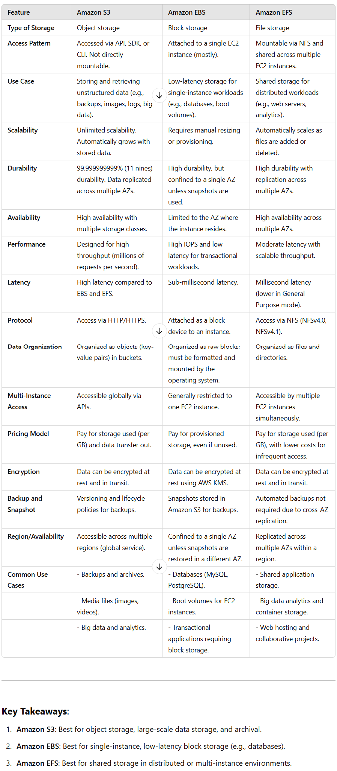
- AWS Identity and Access Management (IAM)
AWS Identity and Access Management (IAM) is a service that helps you securely control access to AWS resources. With IAM, you can define who (identity) has access to what (resources) and under what conditions (policies). IAM is critical for implementing strong security practices in the cloud, ensuring that only authorized users and services can perform specific actions.

Key Features of IAM
- Granular Permissions: Control user access to AWS resources at a very detailed level.
- Shared Access: Grant access to multiple users without sharing credentials.
- Multi-Factor Authentication (MFA): Enhance security by requiring an additional authentication factor.
- Identity Federation: Use external identity providers like Google, Facebook, or corporate directories for authentication.
- Access Logging: Monitor actions using AWS CloudTrail to track who accessed what resource and when.
- Fine-Grained Policies: Use JSON-based policies to define specific permissions for users, groups, and roles.

Core Components of IAM
1. Users
- Definition: Represents an individual person or application interacting with AWS.
- Use Case: A developer, administrator, or an application requiring AWS resource access.
- Authentication: Users have unique credentials, such as passwords or access keys.
- Example: Creating a user named "John" with access to an S3 bucket.

2. Groups
- Definition: A collection of users that share the same set of permissions.
- Use Case: Simplify access management by assigning policies to groups instead of individual users.
- Example: A "Developers" group with permissions to access EC2 and RDS services.

3. Roles
- Definition: A temporary identity assigned to AWS services or users to perform specific tasks.
- Use Case: Assign permissions to services like EC2 to access S3 without embedding credentials in code.
- Example: An EC2 instance role with read-only access to an S3 bucket.

4. Policies
- Definition: JSON documents that define what actions are allowed or denied on AWS resources.
- Types:
  - Managed Policies: Predefined by AWS or created by administrators for reuse.
  - Inline Policies: Attached directly to a user, group, or role for specific use cases.
- Example: A policy allowing s3:GetObject and s3:PutObject actions on a specific bucket.

5. Identity Providers
- Definition: External systems that allow users to authenticate with their existing credentials.
- Types:
  - SAML 2.0: For corporate directories like Active Directory.
  - OpenID Connect: For social login providers like Google.
- Use Case: Simplify user management by integrating with external identity systems.

Types of IAM Access
1. Programmatic Access
- Use Case: For applications or scripts interacting with AWS APIs.
- Authentication: Access keys (Access Key ID and Secret Access Key).
2. AWS Management Console
- Use Case: For users managing AWS services via a web-based interface.
- Authentication: Username and password, optionally secured with MFA.
3. AWS CLI and SDKs
- Use Case: For developers and administrators managing AWS from command-line tools or custom applications.
- Authentication: Access keys or roles.

Best Practices for IAM
- Principle of Least Privilege: Grant users the minimum permissions they need to perform their tasks.
- Enable MFA: Add an extra layer of security for users with sensitive permissions.
- Use Roles for Applications: Avoid hardcoding credentials in applications; use IAM roles instead.
- Regularly Review Permissions: Audit and refine permissions to ensure they're still appropriate.
- Rotate Credentials: Regularly rotate passwords and access keys for added security.
- Monitor with CloudTrail: Track all IAM-related activities using AWS CloudTrail.

Real-World Use Cases
- Secure S3 Access for Teams:
  - Create a "Marketing" group with access to a specific S3 bucket.
  - Add marketing team members to the group.
  - Apply a policy allowing s3:GetObject and s3:PutObject actions.
- Grant Temporary Access:
  - Use roles to give third-party vendors temporary access to specific resources.
  - Example: Granting a contractor limited access to an RDS database.
- Application Access to Resources:
  - Assign an IAM role to an EC2 instance that allows it to read/write to a DynamoDB table.

IAM Pricing
IAM is free to use. However, any AWS resources accessed using IAM credentials are billed based on their usage.

Summary
IAM is a cornerstone of AWS security, enabling precise control over access to AWS resources. It provides flexibility through users, groups, roles, and policies, ensuring that resources are accessed securely and efficiently. For your AWS Practitioner exam, focus on understanding IAM components, access methods, and best practices.

- The Virtual Private Cloud (VPC) service in AWS allows you to create a private, isolated network within the AWS Cloud. It enables you to launch AWS resources like EC2 instances in a secure and customizable virtual network.
VPC helps you control things like:
- IP address ranges
- Subnets
- Route tables
- Network gateways
You can define a network that closely resembles your on-premises network setup, which gives you full control over your network configuration.

Key Components of VPC:
- Subnets: Subnets are segments of a VPC's IP address range where you can place resources like EC2 instances.
  - Public Subnets: Can route traffic directly to the internet (for instances that need internet access).
  - Private Subnets: Isolated from the internet, used for sensitive resources (like databases).
- Route Tables: Control the routing of network traffic within your VPC. For example, how traffic flows between subnets or from your VPC to the internet.
- Internet Gateway (IGW): A gateway used to connect a VPC to the internet. It allows resources in a public subnet to communicate with the internet.
- NAT Gateway: A service that allows instances in a private subnet to access the internet, but prevents inbound internet traffic from reaching those instances.
- Security Groups and Network ACLs:
  - Security Groups: Act as a virtual firewall for EC2 instances to control inbound and outbound traffic.
  - Network ACLs (Access Control Lists): Provide an additional layer of security by controlling traffic at the subnet level.
- VPC Peering: Allows you to connect two VPCs to route traffic between them as if they were part of the same network.
- VPN Gateway: Allows you to securely connect your on-premises network to your VPC over the internet using VPN tunnels.
- VPC Endpoints: Enable private connections between your VPC and supported AWS services, such as S3, without needing an internet gateway or VPN connection.

VPC Types:
- Default VPC:
  - AWS automatically provides a default VPC when you create an account.
  - It comes pre-configured with a public subnet in each availability zone.
  - You can launch instances without needing to configure networking manually.
  - Ideal for users who want to get started quickly without worrying about VPC configuration.
- Custom VPC:
  - A custom VPC is one that you configure yourself.
  - You choose the IP range (CIDR block), subnets, route tables, and security settings.
  - Provides more control and flexibility for complex network architectures.
  - It is ideal when you need more control over your network, security, or need to design a multi-region setup.

Real-Time Example:
Imagine you're hosting a web application on AWS that involves:
- Public-facing EC2 instances (for serving your website) in a public subnet with access to the internet via an Internet Gateway.
- Private EC2 instances (such as a database server) in a private subnet, which does not have direct internet access.
- NAT Gateway in the public subnet to allow the private EC2 instances to download software updates from the internet.
- A VPN Gateway for securely connecting your AWS VPC to your on-premises network for internal company access.

Why Use VPC?
- Security: VPC gives you the ability to isolate resources and secure them using security groups, ACLs, and VPNs.
- Flexibility: You can design a network architecture that fits your needs, from simple setups to highly complex ones.
- Control: With VPC, you have complete control over network configuration, including subnets, IP ranges, and routing.
- Cost Efficiency: You only pay for the resources you provision (e.g., VPN connections or NAT gateways).

Key Considerations:
- CIDR Blocks: Plan your VPC’s IP address space carefully to avoid conflicts in the future.
- Subnets: Properly segment your network into subnets based on usage (public/private) and security requirements.
- Security: Configure security groups, NACLs, and other access controls to ensure that your resources are secure.

- AWS Load Balancer Service Overview
A Load Balancer in AWS is a service that automatically distributes incoming application traffic across multiple targets (like EC2 instances, containers, and IP addresses) in one or more availability zones. This helps to ensure that no single resource gets overwhelmed with too much traffic, thus improving the availability, fault tolerance, and scalability of your application.

Types of Load Balancers in AWS
AWS offers three main types of load balancers, each designed to handle different types of traffic and use cases:
- Application Load Balancer (ALB)
- Network Load Balancer (NLB)
- Classic Load Balancer (CLB)

1. Application Load Balancer (ALB)
Definition:
ALB is designed to handle HTTP/HTTPS traffic and is best suited for web applications where the requests are routed based on the content of the request (like URLs, headers, etc.). ALB works at the application layer (Layer 7) of the OSI model.
Key Features:
- Content-based routing: Routes traffic based on URL path, host, HTTP headers, or query strings. For example, traffic to /api/ can go to one set of servers, while traffic to /images/ can go to another set.
- HTTPS/SSL termination: ALB can handle HTTPS traffic, offloading SSL decryption from your application.
- WebSocket support: Supports real-time communication protocols like WebSocket for persistent connections.
- Routing based on rules: You can create routing rules for directing traffic to different target groups based on the content of the request.
- Health Checks: Regular health checks to ensure that traffic is routed only to healthy instances.
Use Case Example:
- You have a web application with several microservices. ALB can route requests based on the URL path: /user/* routes to a user service, /order/* routes to an order service, etc.
When to Use ALB:
- When you need advanced routing based on URL or host.
- For modern microservices architectures or web applications.
- When you need support for WebSockets or HTTP/2.

2. Network Load Balancer (NLB)
Definition:
NLB is designed to handle high-performance traffic and works at the transport layer (Layer 4) of the OSI model. It is capable of handling millions of requests per second while maintaining ultra-low latencies.
Key Features:
- TCP/UDP load balancing: NLB is suitable for non-HTTP traffic like TCP and UDP traffic (such as applications that use WebSockets, database connections, or custom protocols).
- Static IP support: NLB provides a static IP for your load balancer, which is useful for applications that require fixed IP addresses.
- Zerodowntime: Supports health checks and can automatically reroute traffic to healthy targets without downtime.
- TLS termination: NLB can handle TLS termination for secure traffic.
Use Case Example:
- You have a game server or a VoIP application where the traffic is TCP/UDP-based. NLB can route this traffic efficiently while handling large amounts of concurrent connections.
When to Use NLB:
- When you need high-performance load balancing with low latency.
- For TCP or UDP traffic, such as gaming applications, real-time communications, and databases.
- When you need static IP addresses.

3. Classic Load Balancer (CLB)
Definition:
Classic Load Balancer is the legacy load balancing solution that works at both the application layer (Layer 7) and the transport layer (Layer 4). It is a simpler version compared to ALB and NLB, and AWS recommends moving to ALB or NLB for new applications.
Key Features:
- Basic load balancing: CLB can distribute traffic at the TCP or HTTP/HTTPS layer.
- Limited routing capabilities: Unlike ALB, CLB has fewer routing rules (based on TCP or HTTP requests).
- Sticky sessions: Supports session affinity, where requests from a particular user are sent to the same instance for the duration of their session.
- Health Checks: CLB also offers health checks for routing traffic to healthy instances.
Use Case Example:
- A legacy application or a simple web application that requires basic load balancing.
When to Use CLB:
- When working with legacy applications or EC2 instances that don't require advanced features like content-based routing or WebSocket support.
- For simple use cases where you just need basic load balancing.
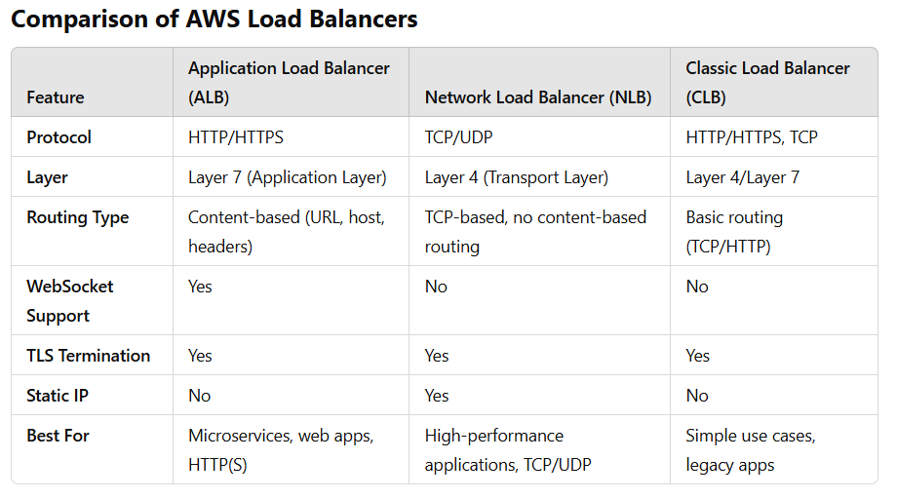
- RDS:
Amazon Relational Database Service (RDS) is a managed relational database service in AWS. It simplifies the process of setting up, operating, and scaling relational databases in the cloud. RDS automates administrative tasks such as hardware provisioning, database setup, patching, and backups, allowing developers and businesses to focus on their applications.

Key Features of Amazon RDS:
- Managed Service:
  - Automates administrative tasks like backups, software patching, monitoring, and scaling.
- Multi-AZ Deployment:
  - Provides high availability by deploying a primary instance and a standby replica in different Availability Zones (AZs). Automatic failover ensures minimal downtime.
- Read Replicas:
  - Improve read performance by creating read-only replicas of the database.
- Scalability:
  - Allows vertical scaling of compute and storage resources based on workload requirements.
- Security:
  - Integrates with AWS Identity and Access Management (IAM), Virtual Private Cloud (VPC), and encryption tools (e.g., AWS KMS for data at rest).
- Performance Optimization:
  - Offers storage options like General Purpose (SSD), Provisioned IOPS (SSD), and Magnetic Storage for performance tuning.
- Monitoring and Metrics:
  - Integrated with Amazon CloudWatch for database monitoring.

Supported Database Engines in Amazon RDS:
- Amazon Aurora:
  - AWS’s high-performance database compatible with MySQL and PostgreSQL.
  - Designed for high scalability and availability with replication across multiple Availability Zones.
- MySQL:
  - Open-source relational database.
  - Popular for web applications and content management systems.
- MariaDB:
  - A community-developed fork of MySQL.
  - Offers additional features and compatibility with MySQL.
- PostgreSQL:
  - Advanced open-source relational database.
  - Known for its extensibility and standards compliance.
- Oracle:
  - Commercial relational database.
  - Offers features like Oracle Enterprise Manager and compatibility with existing Oracle licenses.
- Microsoft SQL Server:
  - A popular commercial database engine.
  - Offers integration with Microsoft applications and tools.

Types of Storage in RDS:
- General Purpose (SSD):
  - Suitable for most workloads with a balance between performance and cost.
  - Baseline performance is measured in Input/Output Operations Per Second (IOPS).
- Provisioned IOPS (SSD):
  - Designed for I/O-intensive workloads like transactional databases.
  - Allows users to specify desired IOPS.
- Magnetic Storage:
  - Legacy option for infrequent access or low-cost storage.
  - Lower performance compared to SSD.

RDS Pricing:
- Pay-as-you-go: Charges are based on the instance type, storage, and additional features like Multi-AZ or read replicas.
- Reserved Instances: Offer cost savings for long-term commitments.
- Free Tier: Includes 750 hours of RDS usage per month for eligible instance types.

Backup and Recovery:
- Automated Backups:
  - RDS performs regular automated backups and allows point-in-time recovery.
- Manual Snapshots:
  - Users can create snapshots of the database manually for long-term backup or disaster recovery.

Monitoring and Management:
- CloudWatch: Provides metrics and alarms for performance monitoring.
- Performance Insights: Offers database tuning and optimization recommendations.

Use Cases:
- Web applications requiring scalable relational databases.
- Enterprise-grade transactional applications.
- Analytical processing with relational data models.
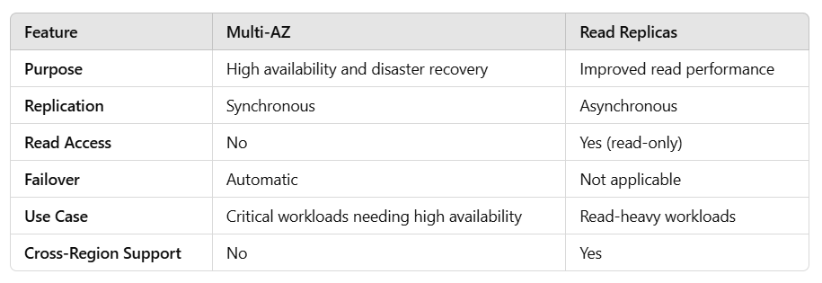

- Difference between durability, agility, availability, and some other words like this uses in aws
ChatGPT said:
ChatGPT
Here’s a clear and concise explanation of commonly used terms like durability, agility, availability, and similar terms relevant to AWS and cloud computing:
1. Durability
- Definition: The ability of a system or service to protect data from loss or corruption over time.
- Example in AWS: Amazon S3 offers 99.999999999% (11 9s) durability, meaning your data is highly unlikely to be lost. This is achieved through automatic replication across multiple facilities.

2. Availability
- Definition: The ability of a system or service to remain operational and accessible during a specific time period.
- Example in AWS: Amazon RDS provides multi-AZ deployments, ensuring high availability by replicating data across availability zones.
- Measured By: Uptime percentage (e.g., 99.99% availability).

3. Agility
- Definition: The ability to rapidly adapt to changing business needs by provisioning or scaling resources on-demand.
- Example in AWS: Launching EC2 instances to scale up your application during peak traffic and scaling them down during off-peak times.
- Why It Matters: Reduces time to market and enables quick experimentation without hardware constraints.

4. Scalability
- Definition: The ability to increase or decrease resources (e.g., compute power, storage) based on demand.
- Example in AWS: AWS Auto Scaling allows your application to handle varying traffic loads without manual intervention.

5. Fault Tolerance
- Definition: The ability of a system to continue operating correctly even if some components fail.
- Example in AWS: Elastic Load Balancer (ELB) can route traffic to healthy instances when one instance fails.

6. Elasticity
- Definition: The ability to automatically add or remove resources to match the current workload.
- Example in AWS: Amazon EC2 Auto Scaling can add instances during high traffic and terminate them when traffic decreases.

7. Resilience
- Definition: The ability of a system to recover quickly from disruptions and maintain operations.
- Example in AWS: AWS Global Infrastructure provides multiple availability zones and regions to ensure resilience in case of regional failures.

8. Security
- Definition: Protecting data, systems, and applications from unauthorized access or breaches.
- Example in AWS: AWS Identity and Access Management (IAM) allows you to control access to AWS resources securely.

9. Global Reach
- Definition: The ability to deploy resources globally across multiple regions and availability zones.
- Example in AWS: AWS has 31 regions and 99 availability zones, allowing users to host applications closer to their customers.

10. Economies of Scale
- Definition: Reducing costs by taking advantage of the scale of operations in AWS.
- Example in AWS: AWS can offer lower prices for storage and compute because of its massive scale compared to traditional infrastructure.

11. Latency
- Definition: The time it takes for data to travel from a source to a destination.
- Example in AWS: Amazon CloudFront reduces latency by caching content at edge locations closer to users.

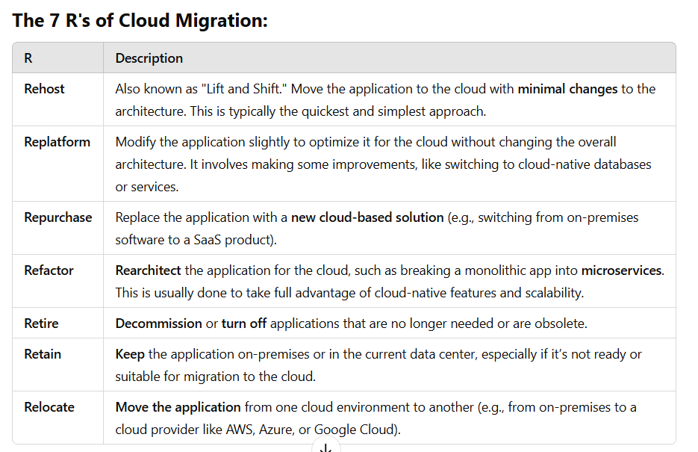

AWS CloudFormation 🏗️ – Infrastructure as Code (IaC) Service
AWS CloudFormation is a service that allows you to define and provision AWS infrastructure using code. Instead of manually creating and configuring AWS resources, you can use CloudFormation templates (written in JSON or YAML) to automate and standardize deployments.

How AWS CloudFormation Works (Step-by-Step)
1️⃣ Write a Template – Define AWS resources (EC2, S3, RDS, IAM, etc.) in a JSON/YAML file.
2️⃣ Create a Stack – Upload the template to AWS CloudFormation.
3️⃣ CloudFormation Provisions Resources – AWS automatically sets up the resources in the correct order.
4️⃣ Manage and Update the Stack – Modify the template to update resources as needed.
5️⃣ Delete the Stack – CloudFormation removes all resources when no longer needed.
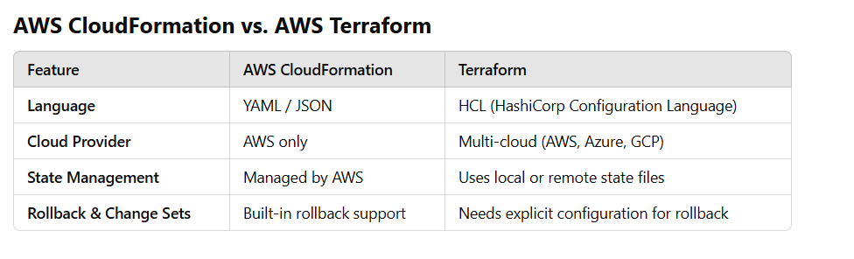
AWS VPC Endpoints
A VPC Endpoint is a way to privately connect your Amazon Virtual Private Cloud (VPC) to AWS services without exposing traffic to the public internet. This improves security and reduces data transfer costs by keeping traffic within AWS’s private network.
Types of VPC Endpoints
- Interface Endpoints
  - Uses AWS PrivateLink to connect your VPC to AWS services like S3, DynamoDB, SNS, SQS, and more.
  - Requires an Elastic Network Interface (ENI) inside your VPC.
  - Traffic stays within the AWS network instead of going over the internet.
- Gateway Endpoints
  - Used specifically for Amazon S3 and DynamoDB.
  - Creates a route table entry to send traffic directly to the AWS service without using an internet gateway or NAT gateway.
Benefits of VPC Endpoints
✅ More Secure – No need for a public IP, Internet Gateway, or NAT Gateway.
✅ Better Performance – Reduces latency by keeping traffic within AWS.
✅ Lower Costs – No data transfer fees for going over the internet.

AWS Storage Gateway is a hybrid cloud storage service that allows on-premises applications to seamlessly use cloud storage. There are four types of AWS Storage Gateway:
- Amazon S3 File Gateway:
  - Provides file-based access to data stored in Amazon S3
  - Supports SMB and NFS protocols
  - Ideal for file shares, data lakes, and backup storage
- Amazon FSx File Gateway:
  - Offers local access to Amazon FSx for Windows File Server
  - Provides low-latency access to file shares
  - Useful for distributed file-based workloads
- Tape Gateway:
  - Replaces physical tape libraries with virtual tape storage in the cloud
  - Compatible with existing backup software that supports iSCSI VTL interface
  - Stores data in Amazon S3 and can archive to Amazon S3 Glacier
- Volume Gateway:
  - Provides iSCSI block storage volumes for on-premises applications
  - Offers two configurations: cached volumes and stored volumes
  - Allows creating point-in-time snapshots of volumes
Each gateway type is designed to address specific use cases and integrate seamlessly with existing on-premises infrastructure. They offer benefits such as:
- Reduced on-premises storage costs
- Improved data durability and disaster recovery capabilities
- Seamless integration with existing applications and workflows
- Enhanced security through encryption and access controls
When implementing AWS Storage Gateway, consider factors like network bandwidth, latency requirements, and data access patterns to choose the most appropriate gateway type for your needs. Always refer to the latest AWS documentation for detailed configuration steps and best practices.
For specific pricing information, performance details, and up-to-date feature availability, please consult the official AWS Storage Gateway documentation or contact AWS support.

What is Migration Evaluator?
- Migration Evaluator is a tool from AWS that helps you figure out how much it will cost to move your workloads from your current on-premises environment (like your physical servers) to AWS.
- It looks at your current infrastructure, collects data about how much you're using, and then compares that to the costs of running those same workloads on AWS.
- It helps you create a business case for migration, showing you how much you could save by moving to AWS. This is useful when you’re planning a cloud migration.
What is TCO (Total Cost of Ownership)?
- TCO is a concept that looks at all the costs involved in owning and running a solution or technology over its entire lifecycle.
- It’s not just about the upfront costs (like buying hardware or software) but also the ongoing costs like maintenance, upgrades, electricity, support, and even when you eventually replace or retire that technology.
- So, it gives you the full picture of how much something will cost you over time.
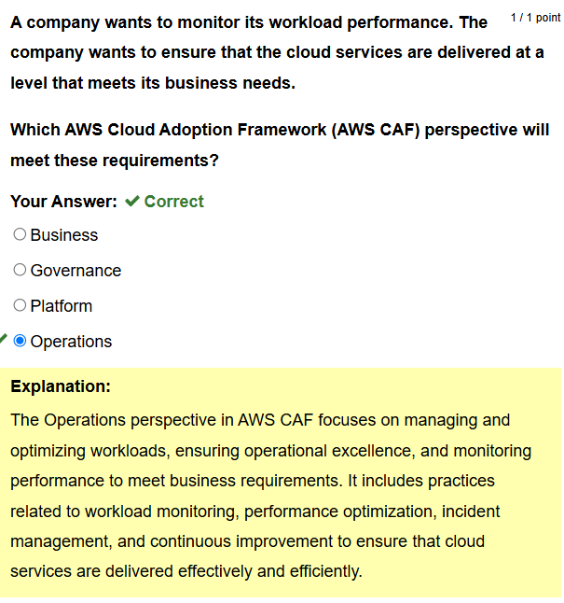
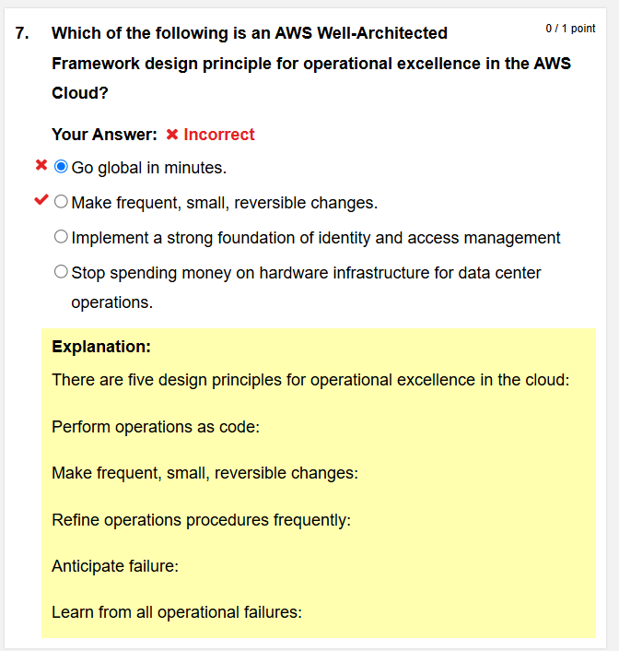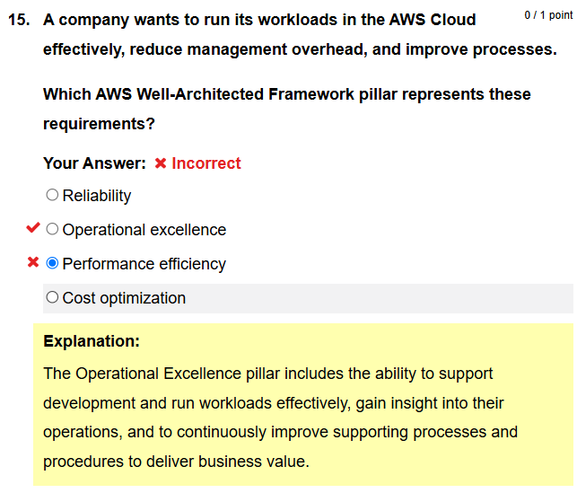
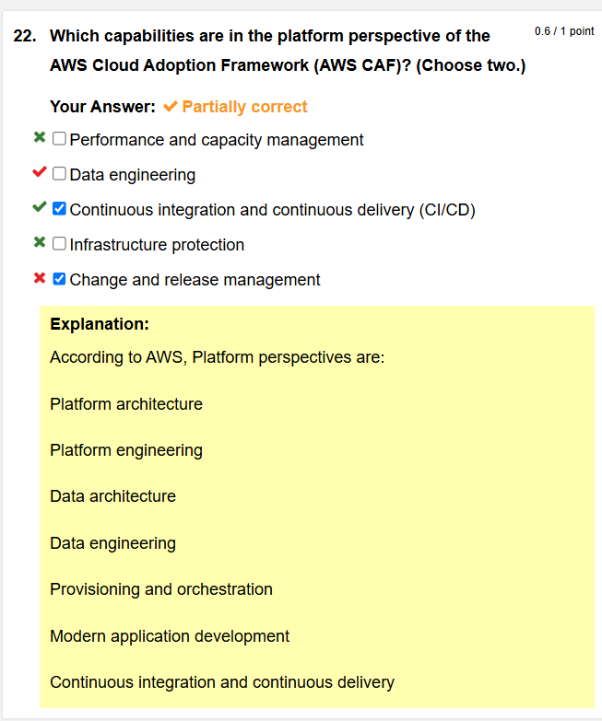
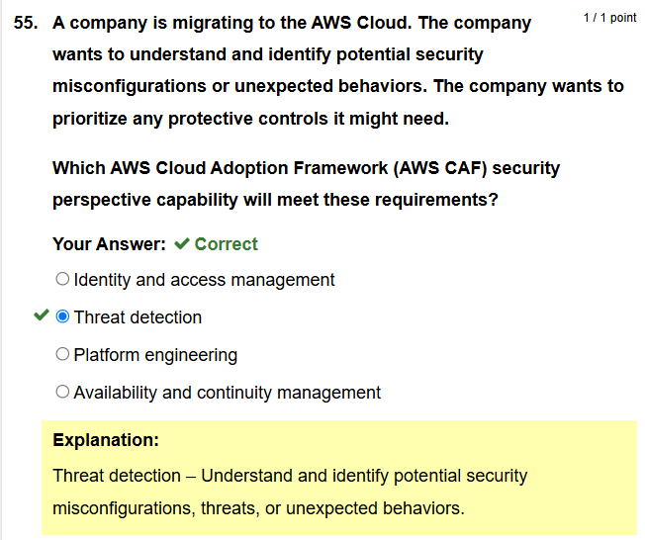
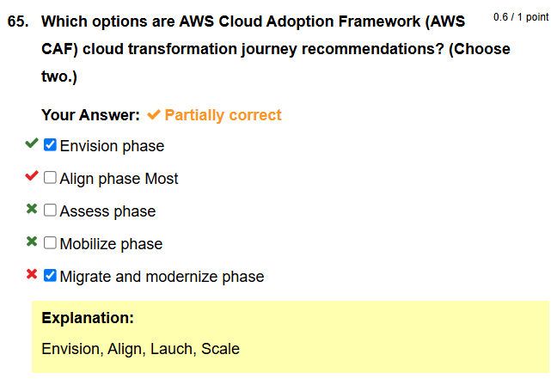
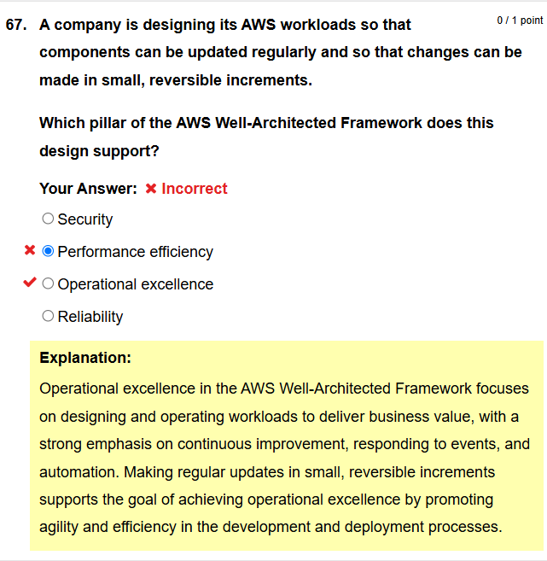
• CodeGuru Reviewer checks for code issues before committing.
• CodeBuild compiles and tests the application.
• CodePipeline automates the release process.
• CodeDeploy deploys the application to the desired environment.
• CodeGuru Profiler monitors performance and optimizes resource usage.
• DevOps Guru provides proactive insights to prevent failures.

